**Objectives:**

At the end of this session, student should able to

1. Identify list of actors from the given case study
2. Identify list of use cases from the given case study
3. Able to construct use case diagram based on answers from (1) and (2)

**Instructions:**

1. This work should be done individually. But you are allowed to discuss with your other colleagues.
2. All your assumption and work (including your calculation) must be clearly stated in this lab sheet.
3. You are required to develop your report using Microsoft Words and Rational Rose (if necessary).
4. Upload your answer at Moodle after the lab session together with hardcopy a day after lab session (Monday) to your lecturer.

**Questions:**

Consider your answer in **Lab Sheet 5 (Requirement Gathering Technique)**, suggest and construct an appropriate interfaces, reports, dialogues and forms for your suggested answers.

You should prepare:

1. Sketch a story board for your suggestion answers.
2. Construct your propose storyboard by using any GUI Software (e.g., Visual Basic, Dreamweaver and etc.)

**Online student marking system**

Interfaces

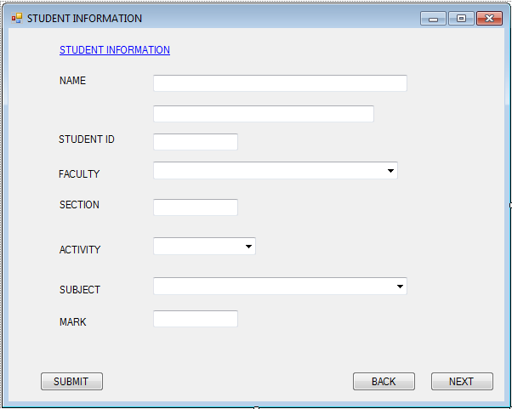

Interface 1

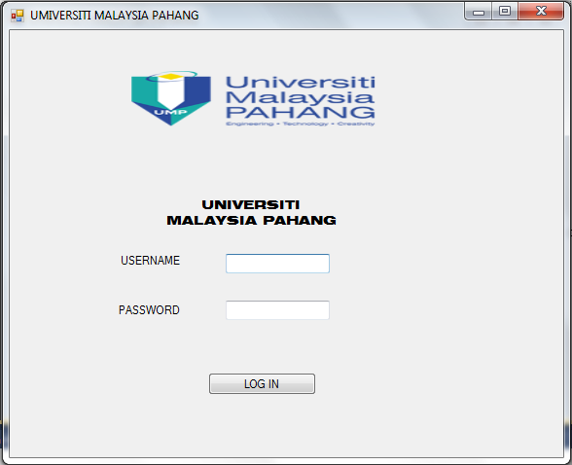

Interface 2



Interface 3

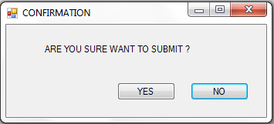

Interface 4

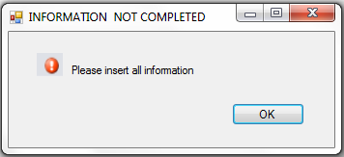

Interface 5

Reports

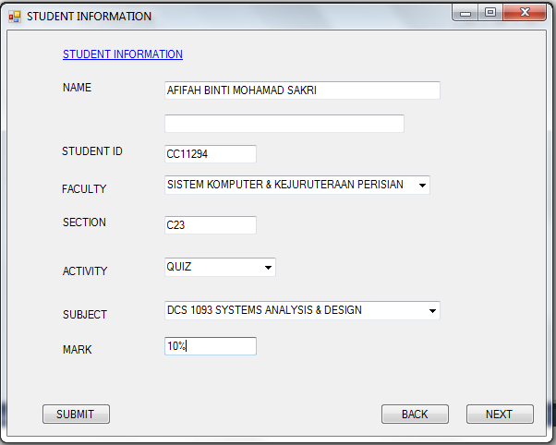

Report 1

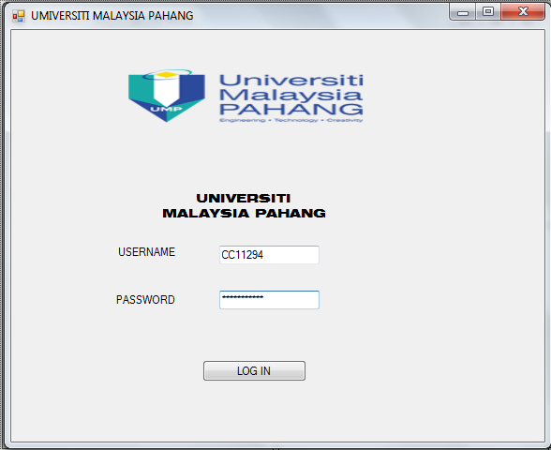



Report 2

Dialogues



Dialogues 1



Dialogues 2

FORMS



Form 1





Form 2